Dairy Project Record Book
Cloverbud (Age 5-7)

Name:

4-H Club:

4-H Leader:

Michigan State University Extension programs and materials are open to all without regard to race, color, national origin, gender, religion, age, disability, political beliefs, sexual orientation, marital or family status.

Age (as of 1/1): Years in 4-H Dairy Project:

Revised 5/2019

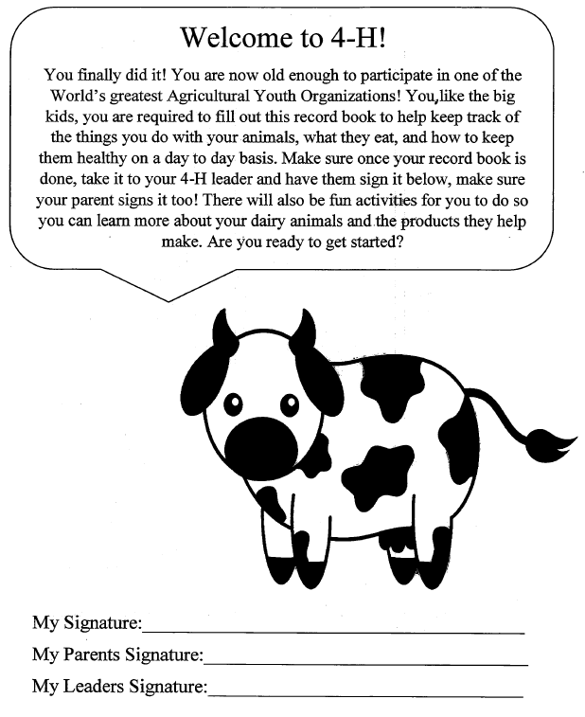

2

You must know both of your Pledges

Fill in the blank spaces with the right words from the

word box to complete both Pledges.

Pledge of Allegiance

I pledge allegiance to the _______________ of the Unites States of

America and to the republic for which it _______________.

One _________________, under God, Indivisible, with ______________

And _________________ for all.

4-H Pledge

I pledge my_____________ to clearer thinking,

My Heart to _______________ loyalty.

My Hands to __________________ ___________________,

And my Health to better living, for my _____________,

My community, my country and my ____________________ .

flag greater liberty world

Head nation service justice

stands larger club

3

Calf Information

When you show a calf, you need to know everything about it.
Tell us all about your calf by filling in the blanks.

My calf’s name is _______________________________________________________

My calf’s birthday is _____________________________________________________

My calf gets fed ____________________ times a day

My calf eats ____________________________________________________________

My calf’s ear tag number is ________________________________________________

My favorite thing about my calf is ___________________________________________

______________________________________________________________________

My calf sleeps on ________________________________________________________

My calf is a ___________________________________ type of dairy breed.

The farm my calf came from is _____________________________________________

4

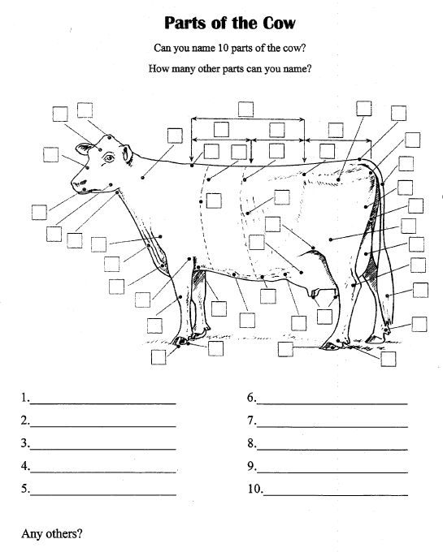

5
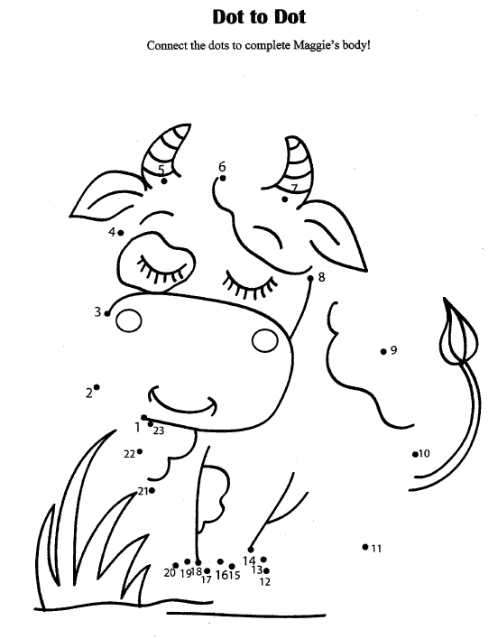

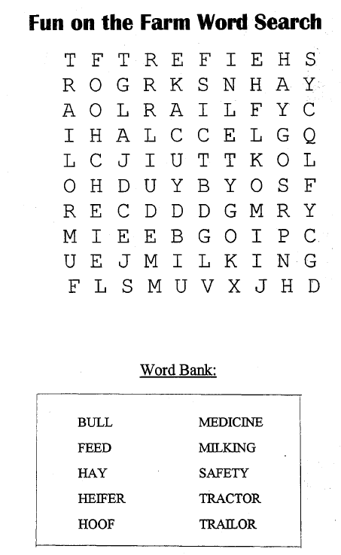

6

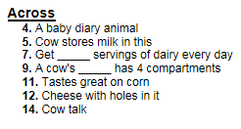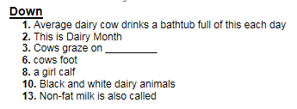

7
Help the milk man get the milk from the farm to the processing plant
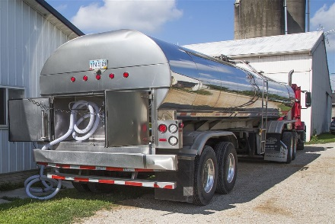
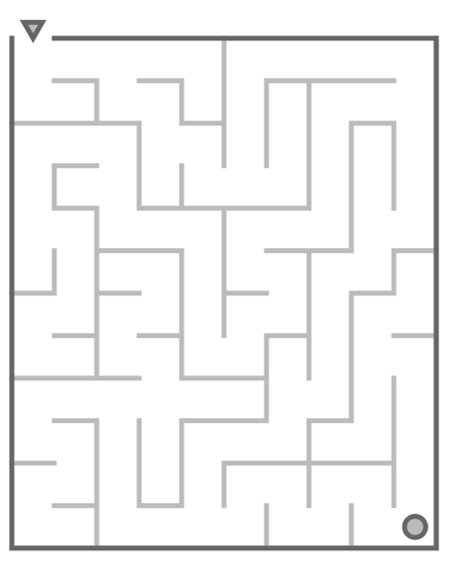

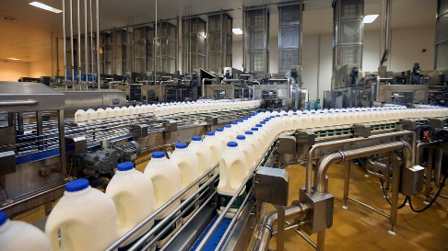8

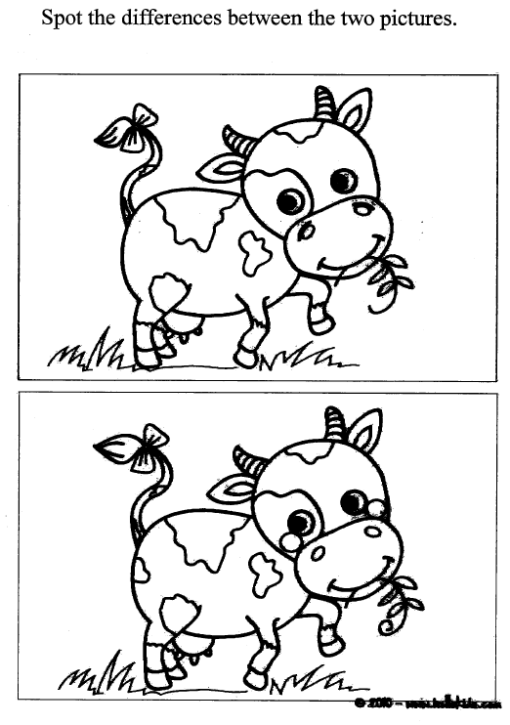

9

Identify the correct breed of Dairy Cow

Write the name of each breed under the picture. Hints at the bottom of the page.

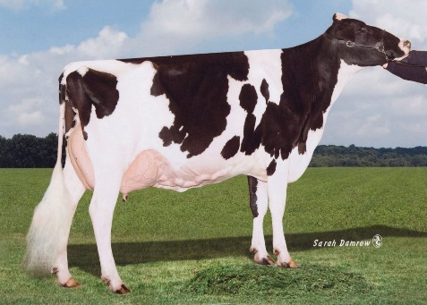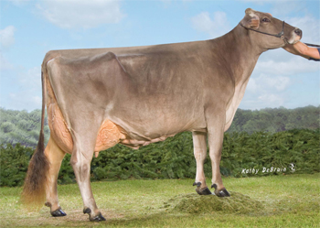

___________________ _____________________

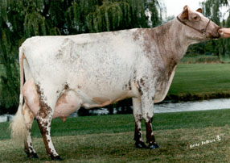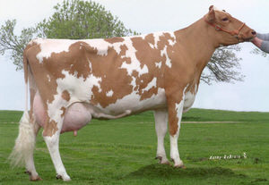

____________________ _____________________

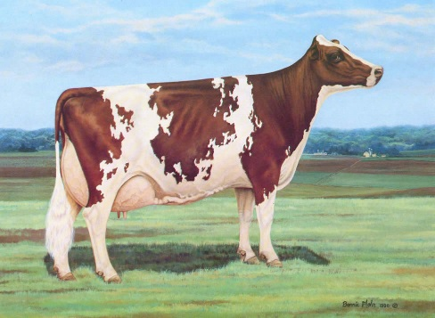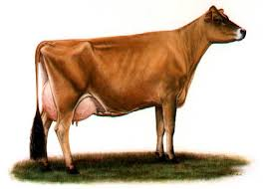
____________________ __________________

Jersey – Known for the high butterfat content of their milk. Generally have a dark switch.

Holstein – Usually black and white OR red and white in color. Originally from the Netherlands. She produces more milk than other dairy breeds.

Ayrshire – Rusty-red and white in color. Because of their adaptability, Ayrshires are found in most parts of the world.

Milking Shorthorn – The Milking Shorthorn is considered a dual purpose breed which can be used for milk or beef production. Large in size, Milking Shorthorn is white and roan in color

Brown Swiss – Kind nature and docile temperament. Their milk is ideal for making cheese because of its high protein-to-fat ratio.

Guernsey – Coloring ranges from fawn to golden. First raised by the monks on the Isle of Guernsey in the English Channel
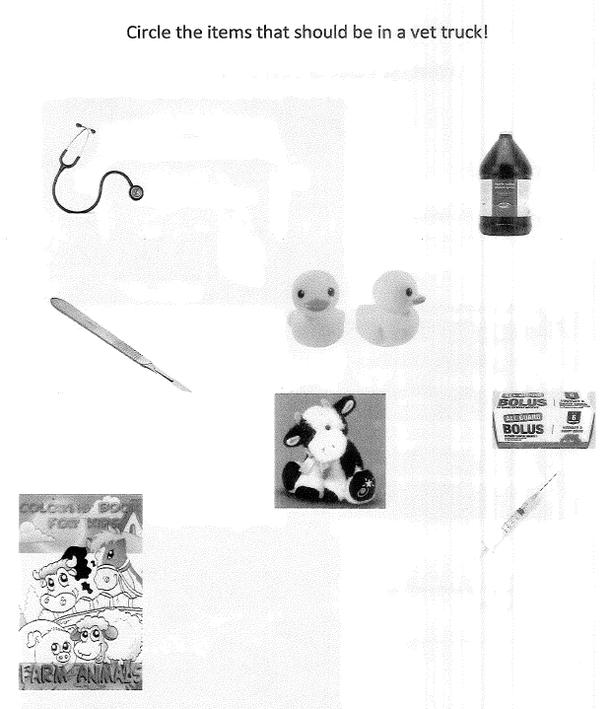

11

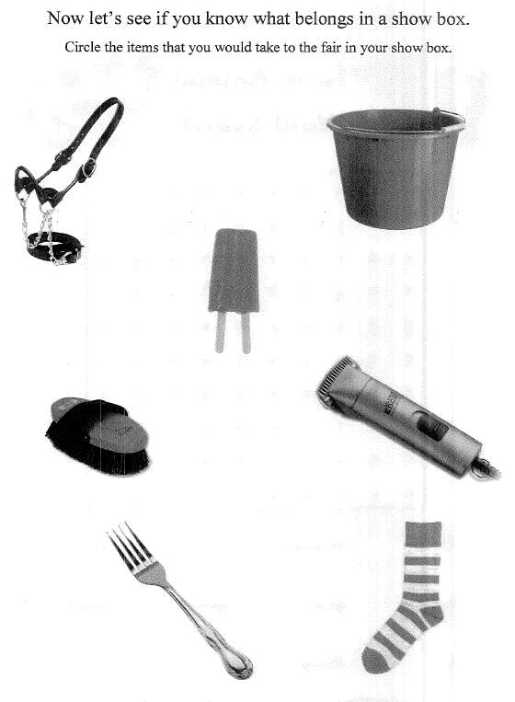
12

Dairy Farm Work Record
Record all of the work you completed for the farm that your dairy project is raised on. For example, what are your farm responsibilities apart from taking care of your 4-H dairy animal?

Description of Work Completed

Dairy Project Photos

Be creative. Show us some photos having FUN with your Dairy project animal. You should also include captions on your pictures that at least include the date of the photograph. The more photos, the better! Add extra pages if you want.

Great Job!

You have completed your record book!!!

If you are having fun and want to keep going,
you can do the following pages ...

Name the Parts
All ages

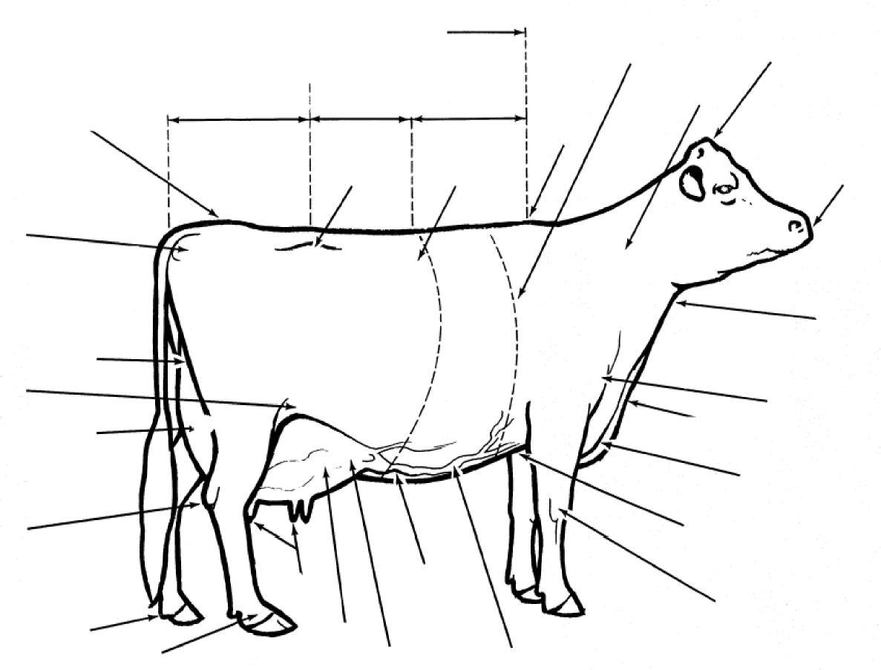
Write the part number on each line.

- Muzzle
- Hip
- Dewclaw
- Brisket
- Throat
- Dewlap
- Knee
- Flank
- Pin Bones
- Heart Girth
- Back
- Rump
- Mammary Veins
- Poll
- Rear udder
- Rear udder attachment
17. Neck
18. Chine
19. Teats
20. Point of Shoulder
21. Foreudder
22. Foreudder attachment
23. Tail Head
24. Loin
25. Milk Wells
26. Hock
27. Chest floor
28. Pastern
29. Barrel
30. Withers

Records Questionnaire
Questions refer to the farm or herd where your animals are housed.
What breed(s) of cattle does the farm have?
How many lactating cows does the farm have? How many dry cows does the farm have?
Total number of heifers and calves on farm?
At what age are calves weaned off milk at this farm?
“Udderly” Fun Matching
Match the words below with the descriptions

A cooling tank where all of the milk from the farm is stores:
The average Guernsey produces...
A cow is dry (not producing milk) for an average of ... A cow milks for approximately...
Silage is...
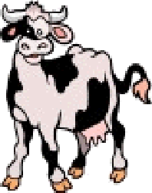
Holsteins are the highest producers of... Jerseys are the highest producers of... Colostrum is...
Forages are...
A calf is milk fed for...
An animal with four stomach compartments:

- Grass or hay used for feed
- Pounds of Milk
- 6-7 Gallons
- Grass compacted & stored in airtight conditions
- 305 Days
- Bulk Tank
- 60 Days
- Butter fat
- The first milk after calving
- 7-8 weeks

Dairy Project Showmanship
How should a dairy animal’s feet be set under them when in the show ring? Draw a picture to show how and then explain next to the picture. You have extra fun and set your animal up the correct way for each type

Dairy bull
________________________________________________________________________________________________________________________________________________________________________________________________________________________________________________________________________________________________________________________________________________
________________________________________________________________________________________________________________________________________________________________________________________________________________________________________________________________________________________________________________________________________________
Dairy Cow
________________________________________________________________________________________________________________________________________________________________________________________________________________________________________________________________________________________________________________________________________________

Dairy Heifer
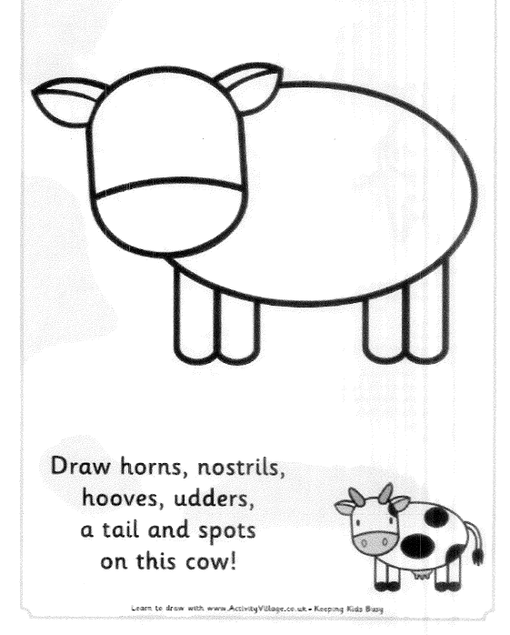

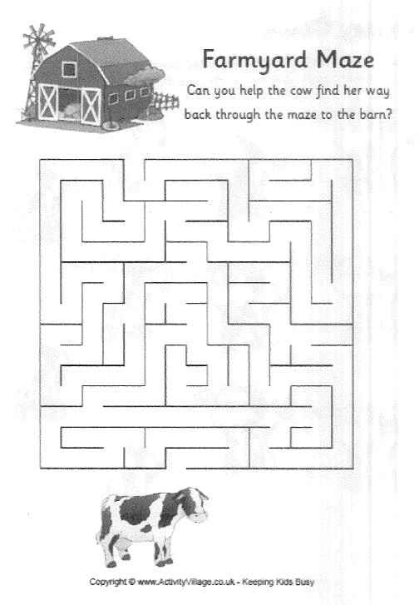

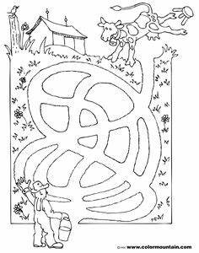
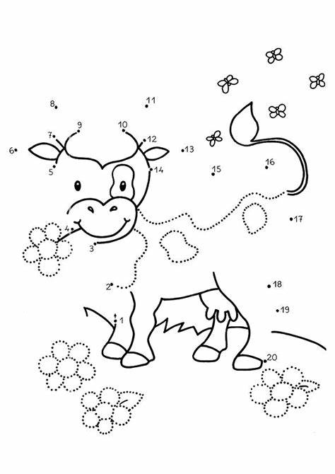
Write a story about you and your animal

____________________________________________________________________________________________________________________________________________________________________________________________________________________________________________________________________
____________________________________________________________________________________________________________________________________________________________________________________________________________________________________________________________________
____________________________________________________________________________________________________________________________________________________________________________________________________________________________________________________________________

____________________________________________________________________________________________________________________________________________________________________________________________________________________________________________________________________
____________________________________________________________________________________________________________________________________________________________________________________________________________________________________________________________________
____________________________________________________________________________________________________________________________________________________________________________________________________________________________________________________________________

